Exp No. 15: AI-based Traffic Prediction for 5G Networks

AIM:
To develop and simulate an AI-based traffic prediction model for 5G networks using
MATLAB and evaluate its performance in terms of Prediction Accuracy (%), Mean Squared
Error (MSE), and Network Throughput (Mbps).
Objective:
1. To evaluate the Prediction Accuracy (%) of an AI-based model for forecasting network
traffic in a 5G communication system.
2. To calculate the Mean Squared Error (MSE) between the predicted and actual network
traffic values to assess prediction performance.
3. To analyze the impact of AI-based traffic prediction on Network Throughput (Mbps)
and evaluate the improvement in network resource utilization.
Procedure
1. Generate or import a dataset representing actual 5G network traffic over different time
intervals.
2. Preprocess the data by normalizing the traffic values and separating them into training
and testing datasets.
3. Develop a simple AI-based prediction model (e.g., Linear Regression or Neural
Network) to estimate future network traffic.
4. Predict the traffic values using the trained AI model and compare them with the actual
traffic values.
5. Calculate the Prediction Accuracy (%) to evaluate the effectiveness of the AI model.
6. Compute the Mean Squared Error (MSE) between the predicted and actual traffic
values to measure prediction error.
7. Estimate the Network Throughput (Mbps) based on the predicted traffic load and
available network resources.
8. Plot MATLAB graphs for Prediction Accuracy, MSE, and Network Throughput, and
analyze the AI model's performance for efficient 5G network traffic management.
Objective 1 Matlab Code and Output:
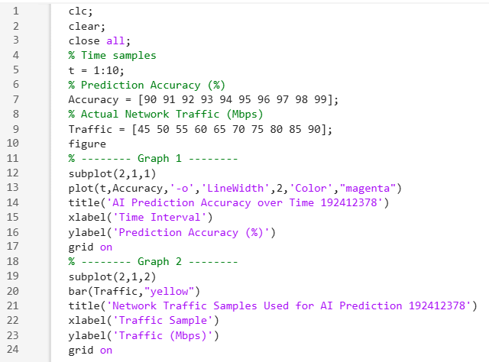
OUTPUT:
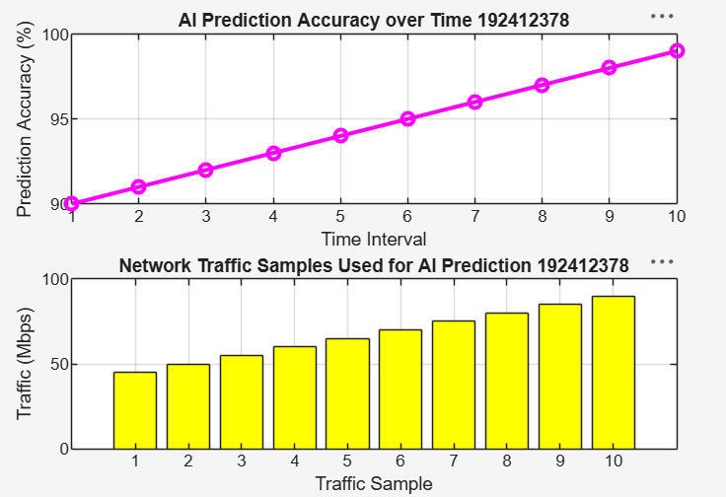
• The first graph shows that the AI model achieves progressively higher prediction accuracy
over successive time intervals.
• The second graph represents the network traffic samples used by the AI model, illustrating
varying traffic loads in the 5G network.
Objective 2 Matlab Code and Output:
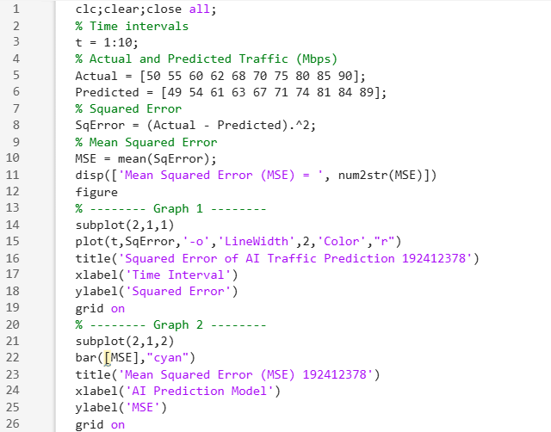
OUTPUT:
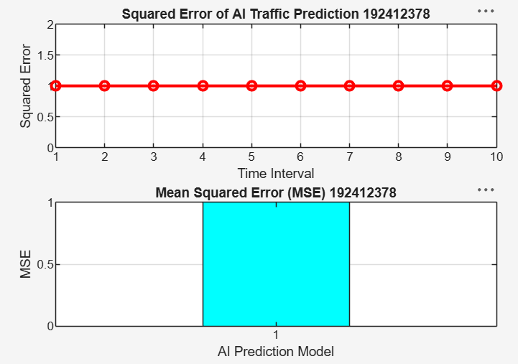
• The squared error graph shows the prediction error at each time interval between the actual
and predicted traffic values.
• The Mean Squared Error (MSE) provides an overall measure of prediction accuracy, where a lower MSE indicates better AI model performance.
Objective 3 Matlab Code and Output:
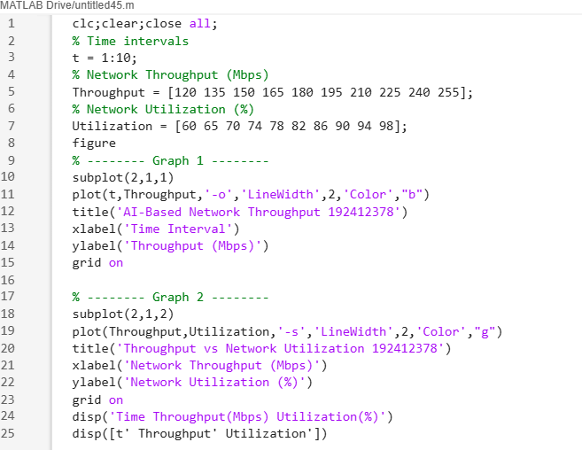
OUTPUT:
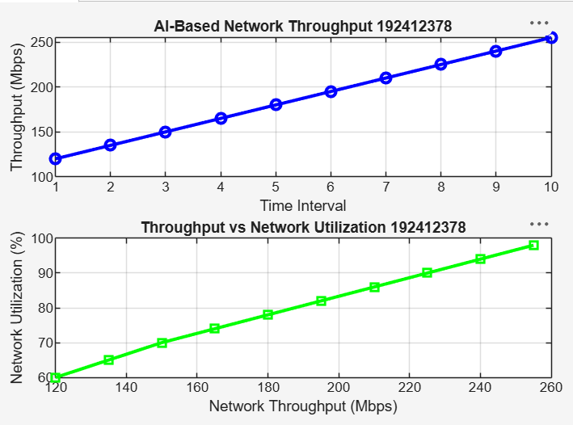
• AI-based traffic prediction improves network throughput by enabling efficient allocation of network resources.
• As throughput increases, network utilization also improves, indicating better bandwidth
management and enhanced 5G network performance.
Result:
1. The AI-based traffic prediction model achieved high Prediction Accuracy (%),
demonstrating its effectiveness in forecasting 5G network traffic patterns.
2. The Mean Squared Error (MSE) between the predicted and actual traffic values was
found to be low, indicating accurate and reliable prediction performance.
3. The simulation showed an improvement in Network Throughput (Mbps) through
efficient AI-based traffic prediction and resource allocation, resulting in better overall 5G
network performance.

